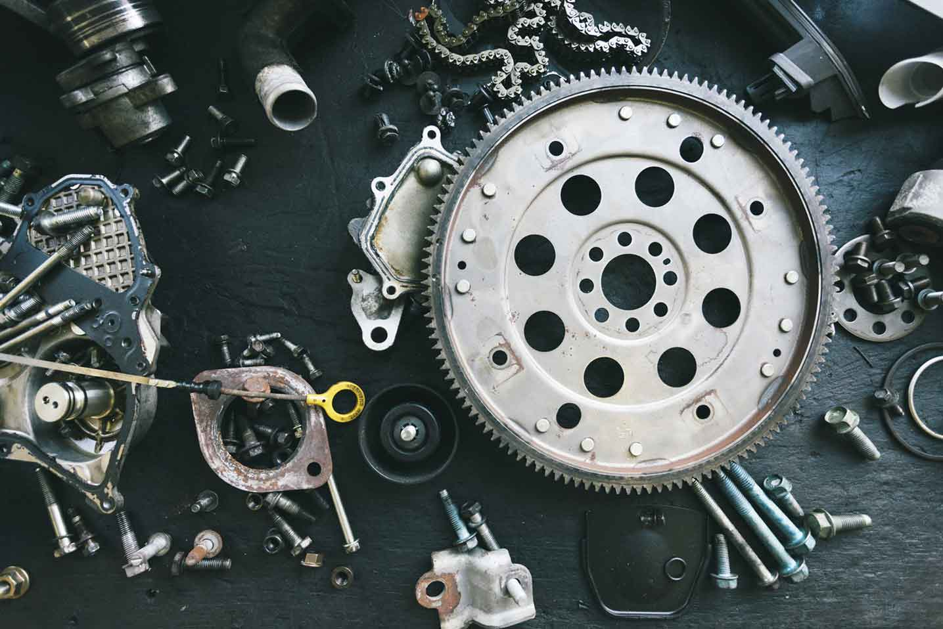­­­­­

|  |  |
| --- | --- |
|  |  |



Process Design

Document

Drayage Assistance Load Match

**Version History**

|  |  |  |  |  |  |  |
| --- | --- | --- | --- | --- | --- | --- |
| Date | Version | Prepare By | Role | Organization | Validated By | Comments |
| 3/4/2022 | 1.0 | Robert (Bob) Rickord | Manager | Matson | N/A | Shared initial copy via email. |
| 3/8/2022 | 1.1 | Robert (Bob) Rickord | Manager | Matson | Raja Kumaravel | Discussed over Teams call. |
| 3/9/2022 | 1.2 | Robert (Bob) Rickord | Manager | Matson | N/A | Shared the document via email |
| 3/16/2022 | 1.3 | Raja Kumaravel | Developer | Matson | N/A | Added/Updated the document |
| 3/18/2022 | 1.4 | Robert (Bob) Rickord | Manager | Matson | N/A | Added/Updated the document |
| 3/21/2022 | 1.5 | Raja Kumaravel | Developer | Matson | N/A | Added/Updated the comments. |
| 4/4/2022 | 1.6 | Raja Kumaravel | Developer | Matson | N/A | Added/Updated the comments. |

Table of Contents

I. INTRODUCTION 4

1.1 Purpose 4

1.2 Objectives 4

1.3 Key Contacts 4

1.4 Minimum Pre-requisites for the Automation 5

II. AS IS Process description 5

2.1 Process Overview 5

2.2 Applications Used 6

2.3 AS IS Process Map 6

2.3.1 High Level Process Map 6

2.3.2 Detailed Level Process Map 6

2.4 Detailed As Is Process Actions - Milo 7

2.5 7

2.6 Detailed As Is Process Actions – Load Match 7

2.7 Input Data Description 19

III. TO BE Process description 21

3.1. Detailed TO BE Process Map 21

3.2. Parallel Initiatives 22

3.3. In Scope For RPA 22

3.4. Out Of Scope for RPA 22

3.5. Exceptions Handling 22

3.5.1. Known Business Exceptions 23

3.5.2 Unknown Business Exceptions 23

3.6. Applications Errors & Exceptions Handling 23

3.6.1. Known Applications Errors and Exceptions 23

3.6.2. Unknown Applications Errors and Exceptions 23

3.7. Reporting 23

IV. Other 24

4.1. Additional sources of process documentation 24

# INTRODUCTION



## Purpose

Develop an RPA to assist Intermodal operations team with covering loads by posting the load opportunity with Load Match.

## Objectives

The business objectives and benefits expected by the Business Process Owner after automation of the selected business process are:

1. Better performance of the overall activity by using the logs provided by the robots.
2. Accelerate the modification process.
3. Decrease manual intervention and gain higher efficiencies.
4. Reduce AHT and Turn Around Time
5. Increase the process accuracy and efficiency.

## Key Contacts

Add here any stakeholders that need to be informed or to approve changes to the process:

|  |  |  |  |
| --- | --- | --- | --- |
| Role | Name | Contact Details (email, phone number) | Notes |
| Process SME | Bob Rickord | [rrickord@matson.com](mailto:rrickord@matson.com), 630-203-3628 | n/a |
| Process Reviewer | n/a | n/a | n/a |
| Process Owner/Approver | n/a | n/a | n/a |

## Minimum Pre-requisites for the Automation

1. Filled in Process Design Document
2. Credentials (username and password) required to login to Milo and Load Match web sites.
3. Access to ibp_leads_dev@matson.com in pre prod server.
4. Access to uipath@matson.com in prod servers.
5. Access to Milogstx website for pre-prod and prod server.
6. Access to Load Match Prod website. No Pre- Prod details.
7. Email ID/Group Mail id for the Bot to receive the load number and send status/exception communication.

# AS IS Process description



## Process Overview

Section contains general information about the process before automation.

|  |  |
| --- | --- |
| Item | Description/Answer |
| Process Full Name | Drayage Assistance Load Match |
| Process Area | Intermodal operations / procurement |
| Department | Intermodal operations / procurement |
| Short Description (operation, activity, outcome) | Load Match Load posting process. On last page post this load needs to be clicked on to actually post the load |
| Process schedule and frequency | As needed when requested by intermodal operations, check mail box every 5 minutes |
| Number of times the process is ran by selected frequency | As needed when requested by intermodal operations |
| Process execution time | 2 min. 4 sec. |
| Process Restrictions | Restriction – Monday through Friday 6AM to 6PM – CDT timezone |
| Peak Period (s) | n/a |
| Number of persons performing the process | 1 |
| Expected Volume increase during next periods | n/a |
| Input data description | ***Load number*** |
| Output Data description | Load post |

## Applications Used

|  |  |  |
| --- | --- | --- |
| Application Name | Environment/ Access method | Comments |
| MiloLogin page | Credital based login | Load number |
| Load Match | not available | Exact purpose |
| Local folder - | not available | not available |
| Excel | Cloud hosting | Used to match rail ramp regions |
| Outlook | Cloud hosting | Used to received load number sending emails for bot |

## AS IS Process Map

This section contains various process maps contributing to a better understanding of how the process is performed pre-automation.

### High Level Process Map

n/a

### Detailed Level Process Map

n/a

## Detailed As Is Process Actions – Milo

|  |  |
| --- | --- |
|  |  |
|  | Est. time: 3.0 sec. |
| image | Action: ClickMilo main Login in screen |

|  |  |
| --- | --- |
|  |  |
|  | Est. time: 3.0 sec. |
| image | Action: ClickEnter Milo User ID |

|  |  |
| --- | --- |
| **Milo Login** |  |
| Login to Milo | Est. time: 0.5 sec. |
| image | Action: Keyboard InputEnter Milo Password |

|  |  |
| --- | --- |
|  |  |
|  | Est. time: 2.4 sec. |
| image | Action: ClickComplete Milo Login |

|  |  |
| --- | --- |
|  |  |
|  | Est. time: 1.5 sec. |
| image | Action: ClickComplete Milo Login |

## 

|  |  |
| --- | --- |
| **MIL_OPS Desktop - Welcome to miLogistx - Google Chrome** | |
|  | Est. time: 8.0 sec. |

|  |  |
| --- | --- |
| **Load order search** |  |
|  | Est. time: 8.0 sec. |
| image | Action: ClickSelect Intermodal Tab |

## 

|  |  |
| --- | --- |
| **MIL_OPS Desktop - Intermodal - Order Search - Google Chrome** | |
|  | Est. time: 6.4 sec. |

|  |  |
| --- | --- |
|  |  |
|  | Est. time: 6.4 sec. |
| image | Action: ClickSelect Office Location – Default to ALL |

|  |  |
| --- | --- |
|  |  |
|  | Est. time: 1.6 sec. |
| image | Action: ClickSelect Office Location – Default to ALL |

## 

|  |  |
| --- | --- |
| **MIL_OPS Desktop - Intermodal - Order Search - Google Chrome** | |
|  | Est. time: 10.6 sec. |

|  |  |
| --- | --- |
|  |  |
|  | Est. time: 1.6 sec. |
| image | Action: ClickClear Salesperson contact information |

## 

|  |  |
| --- | --- |
| **MIL_OPS Desktop - Intermodal - Order Search - Google Chrome** | |
|  | Est. time: 37.5 sec. |

|  |  |
| --- | --- |
|  |  |
|  | Est. time: 28.4 sec. |
| image | Action: ClickSelect Order ID |

|  |  |
| --- | --- |
|  |  |
|  | Est. time: 3.10 sec. |
| image | Action: Keyboard InputEnter Order ID / Load number |

|  |  |
| --- | --- |
| **Find Load Details** |  |
| Select Order ID | Est. time: 1.7 sec. |
| image | Action: ClickSearch for Load |

|  |  |
| --- | --- |
| **Locate Load info** |  |
|  | Est. time: 3.4 sec. |
| image | Action: ClickSelect for Load Details |

## 

|  |  |
| --- | --- |
| **MIL_OPS Desktop - Intermodal - Add Order - Google Chrome** | |
|  | Est. time: 22.4 sec. |

|  |  |
| --- | --- |
| **Orgin pick up information** |  |
|  | Est. time: 5.2 sec. |
| image | Action: ClickLocate Origin pick up location details and copy for input into Load Match pick up location field |

|  |  |
| --- | --- |
| **Equipment information** |  |
| Only select first four characters | Est. time: 2.10 sec. |
| image | Action: ClickLocate equipment type (1st four characters only) for input into equipment field in Load Match |

|  |  |
| --- | --- |
| **Capture CSR Contact information** |  |
| Capture CSR phone and eMAIL | Est. time: 4.9 sec. |
| image | Action: ClickLocation CSR contact link and select for contact information |

|  |  |
| --- | --- |
| **CSR contact information** |  |
| Do not select FAX | Est. time: 9.4 sec. |
| image | Action: ClickSelect CSR contact information only use phone and email for population on last page of load post so carrier knows who to reach out to for additional load information |

## User Logoff option

## Detailed As Is Process Actions – Load Match

|  |  |
| --- | --- |
| * 1. Login to LoadMatch - Google Chrome |  |
|  | Est. time: 1.8 sec. |
| image | Action: Click  User Name – Login |

|  |  |
| --- | --- |
|  |  |
|  | Est. time: 1.6 sec. |
| image | Action: Keyboard Input  Password - Login |

|  |  |
| --- | --- |
|  |  |
|  | Est. time: 2.8 sec. |
| image | Action: Click  Login - Submission |

|  |  |
| --- | --- |
| 1. Account Main Menu - LoadMatch - Google Chrome | |
|  | **Est. time: 6.8 sec.** |

|  |  |
| --- | --- |
|  |  |
|  | Est. time: 6.8 sec. |
| image | Action: Click  Load Posting selection screen |

|  |  |
| --- | --- |
| 1. Load Postings - Google Chrome | |
|  | **Est. time: 7.5 sec.** |

|  |  |
| --- | --- |
|  |  |
|  | Est. time: 7.5 sec. |
| image | Action: Click  Post New Load selection |

|  |  |
| --- | --- |
| 1. Posting Wizard - Google Chrome | |
|  | **Est. time: 29.3 sec.** |

|  |  |
| --- | --- |
|  |  |
|  | Est. time: 16.5 sec. |
| image | Action: Click  Request for Drayage Trucker assistance, always select 1st choice, Bring an Empty |
|  |  |
|  | Est. time: 3.8 sec. |
| image | Action: Click  Equipment Instructions for Drayage Carrier. Always select Either as default |

|  |  |
| --- | --- |
|  |  |
|  | Est. time: 4.5 sec. |
| image | Action: Click  Complete Equipment Instructions for Drayage Carrier. Select continue to move to next screen |

|  |  |
| --- | --- |
|  |  |
|  | Est. time: 4.4 sec. |
| image | Action: Click  Equipment Size selection, enter 1st two Characters from Milo process |

|  |  |
| --- | --- |
| 1. Posting Wizard - Google Chrome | |
|  | **Est. time: 27.2 sec.** |

|  |  |
| --- | --- |
|  |  |
|  | Est. time: 2.2 sec. |
| image | Action: Click  Equipment Type Selection, default to Container (dry) |
|  |  |
|  | Est. time: 4.5 sec. |
| image | Action: Click  Use 1st four characters pulled from MILO for equipment |

|  |  |
| --- | --- |
|  |  |
|  | Est. time: 0.8 sec. |
| image | Action: Keyboard Input  Use 1st four characters pulled from MILO for equipment |

|  |  |
| --- | --- |
|  |  |
|  | Est. time: 4.9 sec. |
| image | Action: Click  Finalize equipment selection process, select continue to move to next screen |

|  |  |
| --- | --- |
|  |  |
|  | Est. time: 2.7 sec. |
| image | Action: Click  Shipper location information (City), input City from Milo data |
|  |  |
|  | Est. time: 2.9 sec. |
| image | Action: Click  Shipper location information (State/Province), input state/province from Milo data |

|  |  |
| --- | --- |
|  |  |
|  | Est. time: 1.2 sec. |
| image | Action: Click  Shipper location information (Zip/Postal), enter zip/postal from Milo data |

|  |  |
| --- | --- |
|  |  |
|  | Est. time: 1.9 sec. |
| image | Action: Click  Shipper Hours for pick up |
|  |  |
|  | Est. time: 1.9 sec. |
| image | Action: Click  Shipper Hours for pick up, default hours – from 8AM to 5PM |

|  |  |
| --- | --- |
|  |  |
|  | Est. time: 2.5 sec. |
| image | Action: Click  Shipper Load Date window for pick up, default to 7 days after first available load date |

|  |  |
| --- | --- |
|  |  |
|  | Est. time: 2.1 sec. |
| image | Action: Click  Shipper Load Date window for pick up (calendar), default to 7 days after first available load date |

|  |  |
| --- | --- |
|  |  |
|  | Est. time: 4.1 sec. |
| image | Action: Click  Driver instructions for type of pick up, Always default to driver stay with |

|  |  |
| --- | --- |
|  |  |
|  | Est. time: 4.5 sec. |
| image | Action: Click  Shipper Info section completion |

|  |  |
| --- | --- |
|  |  |
|  | Est. time: 3.2 sec. |
| image | Action: Click  Drayage carrier Routing information, Always default to RAIL  **Need to add CSR information from MILO data in Contact Name, Phone, Contact Email selection. Missed this step when recording** |

|  |  |
| --- | --- |
|  |  |
|  | Est. time: 2.7 sec. |
| image  MILO SCREEN WITH RAMP LOCATION SO BOT KNOWS WHICH LOADMATCH REGION TO CHOOSE | Action: Click  Drayage Carrier Metro Routing information.  **Table being created to match Milo Ramp data to Load Match Region data** |

|  |  |
| --- | --- |
|  |  |
|  | Est. time: 6.1 sec. |
| image | Action: Click  Drayage Carrier Metro Routing information drop down.  **Table being created to match Milo Ramp data to Load Match Region data for final selection**    **Final Screen Page to post load** |

## Input Data Description

The following table should contain details regarding the inputs that every action of the process takes.

|  |  |  |  |  |  |
| --- | --- | --- | --- | --- | --- |
| #Action | Sample | Input Type | Location | Are inputs Natively Digital*? | Are the Inputs Structured*? |
| Daryage.com | n/a | Original subject name | Email | Yes | n/a |

# TO BE Process description

In this section the proposed improvements to the process, actions to the process will be outlined as well as the actions proposed for automation and the type of robot required. **This will be cross-checked by the Solution Architect.**

## Detailed TO BE Process Map

A detailed process map of the process as it will look like post-automation will be outlined here.

## Parallel Initiatives

The table below will capture the proposed Business, Process or Application changes to be made soon that would impact the process at hand (if any).

|  |  |  |  |  |
| --- | --- | --- | --- | --- |
| Initiative Name | Process Action(s) where it is identified | Impact on current Automation Request | Expected Completion Date | Contact Person |
| n/a | n/a | n/a | n/a | n/a |

## In Scope For RPA

n/a

## Out Of Scope for RPA

The actions **out of scope** for RPA should be listed in the table below together with the reasoning.

|  |  |  |  |
| --- | --- | --- | --- |
| Activity/Action* | Reason for out of scope | Impact on the TO BE | Possible measures to be taken into consideration for future automation |
| *n/a* |  |  |  |

## Exceptions Handling

The Business Process Owner and Business Analysts are expected to document below all the business exceptions identified in the automation process. Exceptions are of 2 types and both need to be addressed:

**Known exceptions** = previously encountered. A scenario is defined with clear actions and workarounds for each case.

**Unknown** = New situation that was not encountered before. It cannot be predicted and in case it happens it needs to be flagged and communicated to an authorized person for evaluation.

n/a

### Known Business Exceptions

Details regarding how the robot should handle the exceptions.

|  |  |  |  |
| --- | --- | --- | --- |
| Exception Name | Action | Parameters | Action to be taken |
| Load / Data issue | n/a | n/a | Email employee who sent email request |
| *n/a* |  |  |  |

### 3.5.2 Unknown Business Exceptions

*n/a*

## Applications Errors & Exceptions Handling

### Known Applications Errors and Exceptions

Details regarding how the robot should handle the exceptions.

|  |  |  |  |
| --- | --- | --- | --- |
| Error/Exception Name | Action | Parameters | Action to be taken |
|  |  |  |  |
| n/a |  |  |  |

### Unknown Applications Errors and Exceptions

*n/a*

## Reporting

In this section all the reporting requirements of the business should be detailed so that when the RPA solution is moved to production the administrators can track the performance of the solution.

|  |  |  |  |
| --- | --- | --- | --- |
| Report Type | Update frequency | Details | Monitoring Tool to visualize the data |
| *n/a* |  |  |  |

# Other

## Additional sources of process documentation

If there is additional material created to support the process automation please mention it here, along with the supported documentation provided.

|  |  |  |
| --- | --- | --- |
| Additional Process Documentation | | |
| Video Recording of the process (Optional) | n/a | Insert any relevant comments |
| Business Rules Library (Optional) | n/a | Insert any relevant comments |
| Other documentation (Optional) | n/a | Insert any relevant comments |
| Standard Operating Procedure(s) (Optional) | n/a | Insert any relevant comments |
| High Level Process Map (Optional) | n/a | Insert any relevant comments |
| Detailed level process map (Optional) | n/a | Insert any relevant comments |
| Work Instructions (Optional) | n/a | Insert any relevant comments |
| Input Files (Optional) | n/a | Insert any relevant comments |
| Output Files (Optional) | n/a | Insert any relevant comments |

